Laptop Price Analysis

Prepared by: Joyce Samuel

Date: 5/5/2026

Introduction
This report presents an analysis of laptop price data collected from Amazon using web scraping techniques. The dataset includes various laptop models along with their prices.
The objective of this report is to understand price distribution, identify the most expensive and cheapest laptops, and analyze average pricing trends across different brands.

Dataset Overview
Total number of products: 379
Price range: ₹12990 to ₹599990
Average price: ₹122890

Top 10 Cheapest Laptops
Name | Price
Certified | Thinkpad T430 Professional Business Laptop | Core i5-3320M | 16GB RAM | 128GB SSD | 14” HD Display | WiFi | Webcam | Win 10 Pro (Core i5-3320m, 128, GB) | ₹12990.0
Certified | T430 Business Laptop | Core i5-3320m | 8GB RAM | 128GB SSD | 14” HD Display | WiFi | Webcam | Win 10 Pro | ₹12990.0
Certified ThinkPad T430s (Slim) Core i5 3320m – 8GB RAM, 128GB SSD 14", Win 10 Pro, Professional Business Laptop | ₹13990.0
Certified | Thinkpad T430 Professional Business Laptop | Core i5-3320M | 16GB RAM | 256GB SSD | 14” HD Display | WiFi | Webcam | Win 10 Pro (Core i5-3320m, 256, GB) | ₹13990.0
FUTOPIA ULTIMUS Pro Intel Celeron Dual Core Laptop 4GB RAM, 128GB M.2 Emmc Expandable~512GB Intel HD Graphics 2.0x1 3.0x1 U + Kaspersky Standard 1 Device 1 Year (Physical Pack) | ₹14435.0
Liquidation Deal Celsius H770 Workstation (No Battery) |Core i7 7th Gen Quad Core Xeon E3-1505M v6 @ | 8GB RAM | 256GB NVME SSD | 4GB Quadro M2200 Graphic | 15.6” FHD | BT | Win 10 | Numeric Keypad | ₹14990.0
Certified | T430 Business Laptop | Core i5-3320m | 16GB RAM | 128GB SSD | 14” HD Display | WiFi | Webcam | Win 10 Pro | ₹14990.0
AXL Laptop (Vayu Book) Newly Launched Thin & Light | 15.6 Inch HD Display (4GB/256GB SSD) | ₹14990.0
Certified & Tested | Pro 6570b Laptop | i5-3320M | 16GB RAM, 128GB SSD | 15.6" HD | Numeric Keypad | Win10 Pro | ₹14990.0
Certified | T430 Business Laptop | Core i5-3320m | 8GB RAM | 256GB SSD | 14” HD Display | WiFi | Webcam | Win 10 Pro | ₹14990.0

Top 10 Expensive Laptops
Name | Price
Alienware 16 Area-51 Gaming Laptop AA16250-16 WQXGA 240Hz Display, Intel Core Ultra 9-275HX, 32GB DDR5 RAM, 1TB SSD, NVIDIA GeForce RTX 5070Ti, Windows 11 Home, Onsite Service - Liquid Teal | ₹599990.0
Alienware Area-15 Gaming Laptop,Intel Core Ultra 9 275HX+24GB RTX 5090,64GB,2TB SSD with Logitech G502 LS Wireless Gaming Mouse, 25000DPI Programmable and Logitech GProX Wired Gaming Headset | ₹528280.0
MSI Raider Gaming Laptop,Intel Core Ultra 9 285HX+24GB RTX 5090,64GB,4TB SSD with Logitech G502 LS Wireless Gaming Mouse, 25000DPI Programmable and Logitech GProX Wired Gaming Headset | ₹519280.0
ASUS ProArt P16 OLED (2025), AMD Ryzen AI 9 HX 370, RTX 5090-24GB,64GB RAM, 2TB SSD, 16"/40.64cm Touchscreen, 4K, 120Hz,Windows 11,M365 Basic (1Year)*/Office 2024, Nano Black, 1.95Kg,H7606WX-SE028WS | ₹503990.0
ASUS ROG Strix SCAR 18,Intel Core Ultra 9 275HX Gaming Laptop(NVIDIA RTX 5090-24GB/175W TGP/64GB/2TB/2.5K QHD+/18"/240Hz/Windows 11/M365 Basic(1Year)*/Office Home 2024/Off Black/3.30 Kg)G835LX-SA187WS | ₹499990.0
MSI Raider 18, Intel Series 2 Core Ultra 9 285HX, 46cm UHD+ 120Hz Gaming Laptop (64GB/4TB NVMe SSD/Windows 11 Home/NVIDIA GeForce RTX 5090, GDDR7 24GB/Core Black/3.6Kg) A2XWJG-253IN | ₹499990.0
Apple 2026 MacBook Pro Laptop with M5 Max chip with 18‑core CPU and 40‑core GPU: Built for AI, 41.05 cm (16.2″) Liquid Retina XDR Display, 48GB Unified Memory, 2TB SSD Storage; Silver | ₹499900.0
Apple 2026 MacBook Pro Laptop with M5 Max chip with 18‑core CPU and 40‑core GPU: Built for AI, 41.05 cm (16.2″) Liquid Retina XDR Display, 48GB Unified Memory, 2TB SSD Storage; Space Black | ₹499900.0
Alienware 16 Area-51, Intel Core Ultra 9-275HX, RTX 5090-24GB, 64GB DDR5, 2TB SSD, WQXGA, 16.0"/40.64cm, 240Hz, Win 11, MSO 2024, Liquid Teal, 3.4kg, AI Enabled, 500 nits, AI PC | ₹493490.0
Lenovo Legion 9 Intel Core i9-13980HX 16" (40.64cm) 3.2K Mini LED 1200Nits 165Hz Gaming Laptop (32GB/2TB SSD/NVIDIA RTX 4090 16GB/Black/2.5Kg), 83AG0044IN +GB700 Backpack | ₹453835.0

Price Statistics
The boxplot shows the statics of laptop prices.
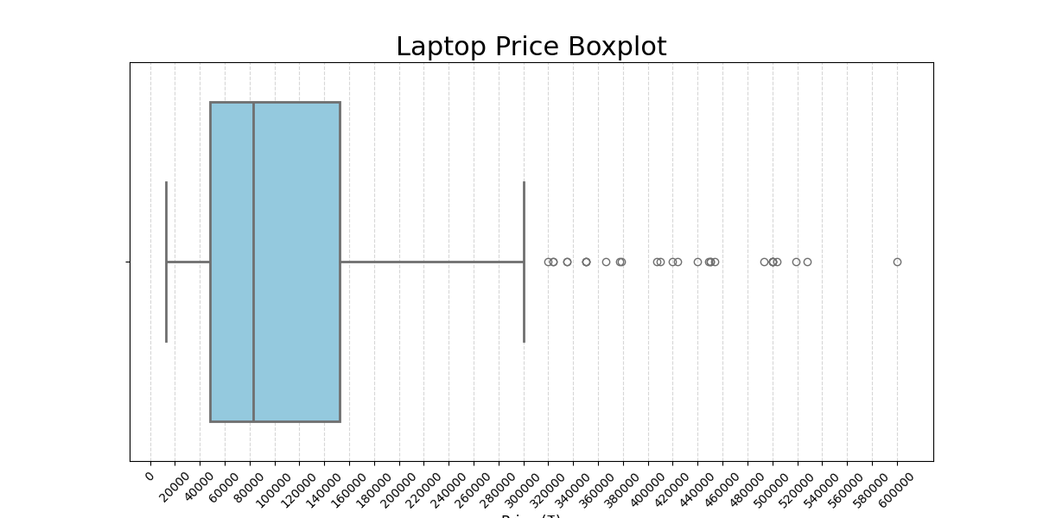

Price Distribution
The bar chart represents the comparison of laptop prices across selected products.
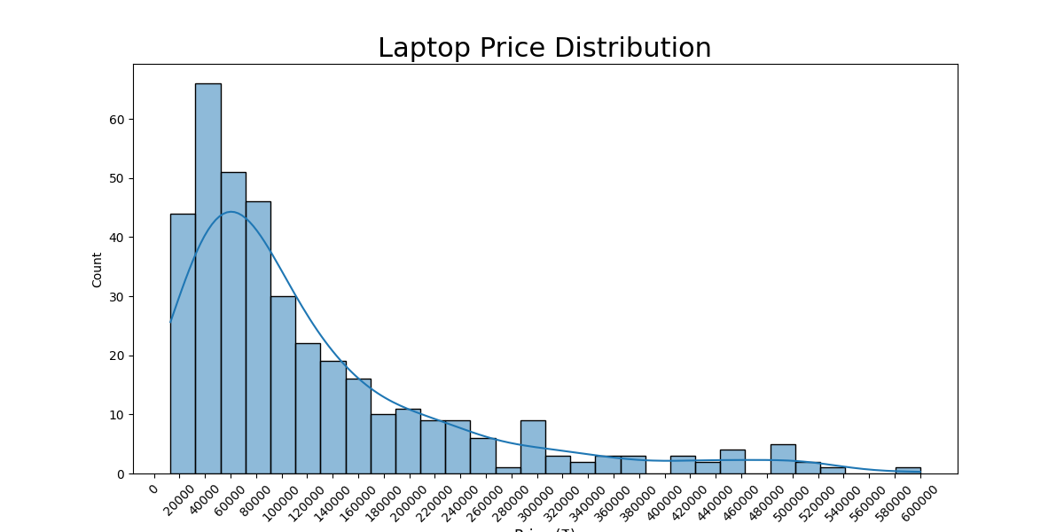

Average Price by Brand
Brand | Average Price
Primebook | ₹24490.0
Dynabook | ₹39704.29
Unknown | ₹55270.47
HP | ₹86961.25
Acer | ₹106052.21
Lenovo | ₹108183.64
Samsung | ₹116740.0
Dell | ₹141479.53
Asus | ₹164448.59
MSI | ₹199913.39
Apple | ₹299622.73
ALIENWARE | ₹403777.5
It can be observed that Apple and Alienware laptops have the highest average price, while brands like Lenvo, Acer and Hp offer more budget-friendly options.

Key Insights
- Most laptops are priced between ₹20,000 and ₹1,00,000.- A few premium laptops exceed ₹3,00,000, acting as outliers.- Lenovo and HP dominate the dataset in terms of number of products.- Budget laptops are mostly under ₹80,000.
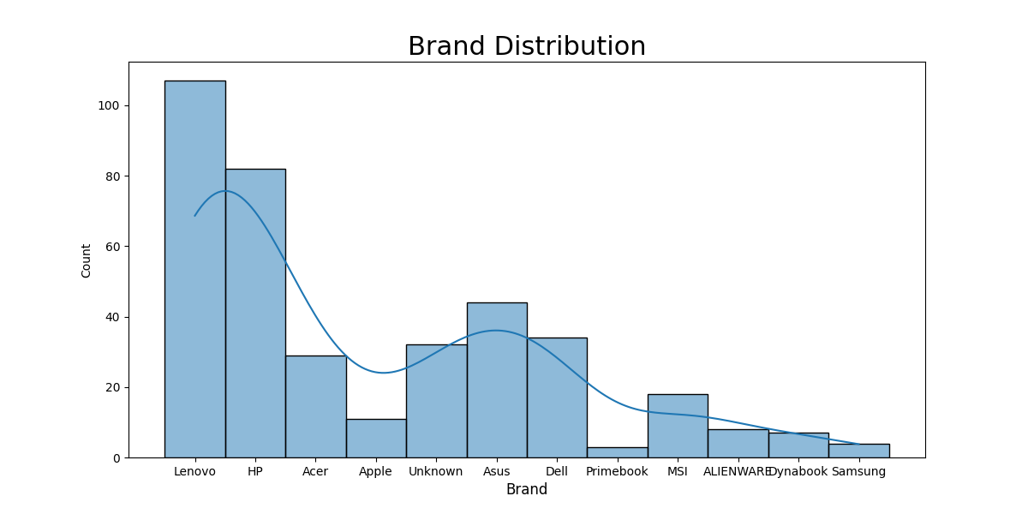

Conclusion
In conclusion, the analysis shows a wide variation in laptop prices depending on brand, specifications, and category.This data can help customers make informed purchasing decisions and understand market trends.

